# California State University, Fresno

# DEPARTMENT OF COMPUTER SCIENCE

|  |  |  |  |  |  |
| --- | --- | --- | --- | --- | --- |
| Class: | **Algorithms & Data Structures** | | | Semester: | **Fall 2021** |
|  | | | | | |
| Points |  | Document author: | **Saishnu Ramesh Kumar** | | |
|  | Author’s email: | **saishnu_rk@mail.fresnostate.edu** | | |
| Laboratory number: | **Section 1, 11am to 12:50pm** | | |
|  | | | | | |

**1. Statement of Objectives**

The objective of this assignment was to get the shortest path possible for the Dijkstra algorithm. This algorithm would compute the shortest path from the single source vertex to the other vertices and this does not work for negative edge weights. This algorithm is somewhat new to me as I have heard of it before and did not learn much about it until watching the lecture and completing this lab assignment.

**2. Experimental Procedure**

A macro was created in the beginning followed by the three function: minDistance, dijkstra, and print. The minDistance function locates the vertex using the minimum distance. The dijkstra function would implement the single shortest path algorithm to get the distance. The print function prints out the end output/result of the program. In the main function, the graph was created, and the needed function was called to display the output.

**3. Analysis**

Screenshot Terminal Output:

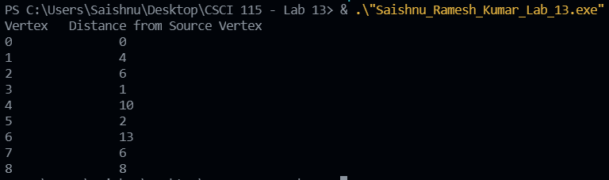

**4. Encountered Problems**

The only problems I encountered were compile errors and some logical errors here and there but they were fixed and resolved.

**5. Conclusions**

To conclude, I have got a better understanding about how both of this algorithms works and it is interesting to learn how it functions.

**6. References**

Slides provided by TA.

Slides provided by professor.

<https://www.geeksforgeeks.org/dijkstras-shortest-path-algorithm-greedy-algo-7/>

<https://www.youtube.com/watch?v=XB4MIexjvY0>